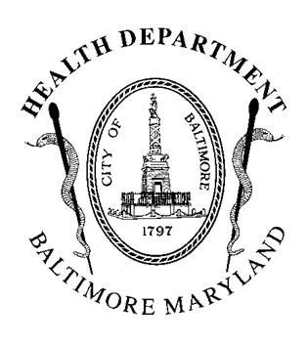
BCCHEC Notes
October 24th, 2016
Baltimore City Health Department
In Attendance: Toni Brafa-Fooksman, James Zabora, Emilie Gilde, Rhonda Silva, Rebkha Atnafou, Lee Bone, LaVerne Perry, Rafael Guerrero-Preston, Norma Kanarek
Agenda Items
Welcome and Introductions
Coalition Business
- Colorectal Screening Project with Park West
  - BCHD awarded $35,000 to work with FQHC’s in Park West Community
  - The purpose of this award is to increase colorectal cancer screening rates among the age appropriate patient populations served by health centers, regardless of insurance status.
  - BCHD will work in partnership with American Cancer Society and Urban Health Institute
- Urban Health Institute will be conducting outreach for colorectal cancer on the West side as part of a new grant they were awarded
- Review of Resource Guide
  - Leukemia and Lymphoma Support Group information out of date
  - Will further review at Core Group meeting on November 18th, from 8:30-10 am
“Precision Medicine Tools for Cancer Prevention and Control”
Rafael Guerrero-Preston, PhD, Assistant Professor
Johns Hopkins School of Medicine
Department of Otolaryngology Research

“Decreasing Distress and Improving Quality of Life Among Newly Diagnosed African American Cancer Patients and Their Family Members”
James Zabora, ScD
Sidney Kimmel Comprehensive Cancer Center
Johns Hopkins Center to Reduce Cancer Disparities
Director, Community Outreach & Education

Partner Updates
- Rebkha Atnafou with the Urban Health Institute is looking to recruit survivors of colorectal cancer to complete a survey. Participants will be compensated.
- Check out the Urban Health Institute’s new PSA at https://youtu.be/HeA7KgSQRtA
- The core group will be meeting November 18th 8:30-10:00 am at Baltimore City Cancer Program @ UMGCC (4538 Edmondson Ave., Baltimore, Maryland 21229) to plan for upcoming meetings, review potential funding opportunities for the coalition, and finalize the resource guide.
- The next coalition wide meeting will be in January 2017 – date/time/location TBD.

